Chili non Carne with Masa Flatbread

[Get this meal!](https://www.thepurplecarrot.com/users/sign_up) 

Ingredients

1. 1/2 cup masa harina
2. 1/4 teaspoon baking powder
3. 3 tablespoons extra virgin olive oil*
4. Salt and pepper *
5. 8 ounces tempeh
6. Fresh oregano
7. Fresh chile
8. 1 onion
9. 2 cloves garlic
10. 1/2 teaspoon ground cumin
11. 1 tablespoon chili powder
12. 1 small can kidney beans
13. 1 can crushed tomatoes
14. 1 can crushed tomatoes
15. Fresh cilantro
16. 2 scallions
17. Napa cabbage leaves
18. 1 lime
19. *not included

SUMMARY

* Prep time: 35 minutes
* Servings: 2

NUTRITION

* Calories: 740
* Carbohydrates: 85
* Fat: 30
* Protein: 41

“Chili” is almost as hard to define as “salad”—there are a million versions, and we’ll show you a few this winter. Among my favorites is this super hearty tempeh-bean variation, served with a crisp masa flatbread that’s reminiscent of a South American arepa. When you brown crumbled tempeh, it not only gets a meaty texture, but also lays a beautiful foundation of flavor for the stew. And topping everything with crunchy cabbage and sparkly cilantro adds unexpected freshness.

Instructions

1.

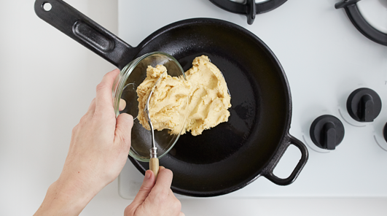

Heat oven to 425°F. Combine the masa harina, baking powder, 1⁄4 teaspoon salt, and a little pepper in a medium bowl. Add 1 tablespoon oil and stir with a fork until the mixture looks like coarse meal. Stir in 1/2 cup water to make a thick batter. Put a medium oven-safe skillet over medium-high heat and add 1 tablespoon oil. When it’s hot, add the masa mixture, spread it evenly, and put the pan in the oven, even if it is not up to temperature yet. Bake until the center is firm and the top is crusty, 15 to 20 minutes

2.

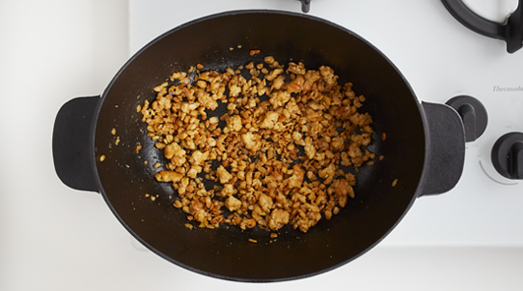

Put a medium pot over medium-high heat and add 1 tablespoon oil. When it’s hot, crumble the tempeh into the pot and cook, stirring frequently and breaking up the pieces, until they’re well browned, 7 to 10 minutes.

3.

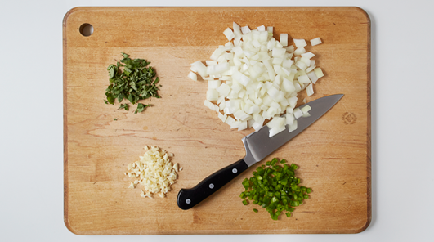

Rinse and drain the beans in a colander. Rinse about half the oregano, strip the leaves from the stem and chop. Rinse, stem, seed, and chop the chiles. Trim and peel the onion, and chop it and the garlic. When the tempeh is ready first add the onion and cook, stirring occasionally, until soft, 3 to 5 minutes. Add the garlic and some or all of the chile (depending on your affinity for heat) and cook, stirring, until they soften a little, another minute or 2.

4.

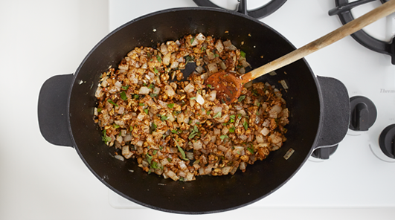

Stir in the cumin, chili powder, and 1 tablespoon of the oregano (save the extra for another use), and cook, stirring until fragrant, about a minute. Add the beans, tomatoes, and 1/2 cup water. Bring to a boil, then lower the heat so the liquid bubbles steadily but not violently. Add a pinch of salt and pepper. Cook, stirring occasionally and adding more liquid if necessary, until the beans are very tender and the flavors have mellowed, 15 to 20 minutes.

5.

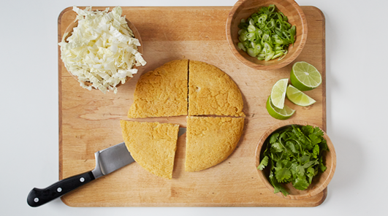

Rinse, dry, trim, and chop the cilantro and scallions. Rinse and dry the cabbage leaves and slice them crosswise into thin ribbons. Rinse and quarter the lime. Remove the masa cake from the oven and slide it out of the pan onto cutting board. Cut into wedges and serve the chili with some masa cake, topped with cilantro and cabbage, and garnished with lime wedges.